**Experimental analysis of corruption in auction procurements**

|  |
| --- |
|  |

**Content**

Introduction 3

1 Defining corruption 3

1.1 How procurement auctions are conducted 4

1.2 Corruption in procurement 4

1.3 Theoretical background 5

2 Data 6

3 Detection of corruption 6

4 The model 11

4.1 Testing the model 12

5 Limitations 13

Conclusion 14

References 15

# **Introduction**

## **1 Defining corruption**

Corruption is recognized as a widespread issue and a major obstacle to growth and development which tends to be higher for developing and transitioning economies due to the lack of regulation and control (Shleifer, Vishny 1993).

Corruption can be simply defined as “Misuse of public office for private or political gain” (Rose-Ackerman 1999).

According to The World Bank corrupt practice in procurement is defined as “the offering, giving, receiving or soliciting, directly or indirectly, of anything of value to influence the action of public official in the procurement process or in contract execution”. OECD estimate that corruption in public procurement reduces national procurement budgets roughly by 20-25%[1].

In context of public procurement, corruption is expressed via auctioneer twisting the outcome of an auction in favour of some bidder in exchange for bribe. It is a widespread issue all over the world since it creates entry barriers and thus restricts competition by not allowing eligible firms from participating in the auctions and winning contracts. Existing evidence (O. Compte, A. Lambert-Mogiliansky and T. Verdier, 2005 8; Olken and Pande, 2012) also supports given claim and states that corruption in public procurement often leads to inefficient allocation of public funds. Moreover, sometimes collusion between corrupted firm and public official may result in deterioration of quality of services provided (materials, goods) while pushing the price paid up.

This paper analyses and investigates the effect of corruption on competition in procurement in Russia. Russian context is no different from the rest of the world and it order to understand consequences of corruption there it is enough to recall the scandal concerning embezzlement of 256 billion rubles from the state budget during the construction of the Moscow Ring Road for which no one has been held responsible for so far.

Moreover, regarding corruption in public procurement, it can be recalled that Russian transport infrastructure market maintains inefficient methods of road pavement construction which cause their lifecycle to be not more than 3 years without repair which is lower than a lifecycle of roads in EU countries while the cost of construction, in turn, appears to be many times higher. This happens the use of non-optimal modifiers or due to their scarcity as a state-owned monopolistic road construction company allows to produce only one type of modifier which is unsuitable for low temperature conditions. Moreover, tenders for the supply of this modifier are consistently won by the same several companies directly or indirectly associated with the director of the same state companies (headed by his wife, close partners). Thus, presence corruption patterns in Russian public procurement allows to intentionally limit competition between manufactures and as a result reduces lifetime of Russian roads.

# **1.1 How procurement auctions are conducted**

Auctions are an efficient mechanism to procure. In relation to procurement auctions, the auctioneer is represented by government official while bidders correspond to firms who participate in the auction. The timeline of every procurement auction is as follows: firstly, the auctioneer arranges procedure and a maximum possible price; afterwards firms start their bidding either competing with each other or anonymously and finally, after the end of the bidding process, the contract is assigned to a firm with a lower bid.

Russian public procurement corresponds to 6.8 trillion rubles[2] and is roughly 8% of GDP for 2018. Majority of given contracts are conducted through actions. In order to monitor activity and reduce probability of corruption government uses regulation (Federal law №44 which was imposed in 2013 right after Federal law №94 (2005)). According to given regulation public must be given all procurement information thus all procurement auctions above hundred thousand rubles must be conducted through similar competitive procedure and all the information concerning the matter of an auction, its timeline, number of bidders, winning firm and a starting price is published on specific (and centralized for whole Russia) website which is going to be used during the analysis in a given paper[3]. Moreover, electronic bidding system is being implemented during last few years and one of the recent legislative changes made was forcing almost all types of procurements to be conducted in an electronic form.

There are three types of frequently used auctions in Russian procurement: requests for quotation (first price sealed bid auctions which can be used only for auctions below 500 thousand rubles), open electronic auctions (corresponds to an online English action and can be used for any auctions and are obligatory for the ones above 500 thousand rubles) and open tenders (first price sealed-bid auctions with also taking into account quality which bidder can provide). This work focuses on sealed-bid auctions which usually are used for procurement of office supplies, street cleaning and other types of needs of public agencies. The timeline of this particular type of auction is as follows: auctioneer (public body) posts a notice with requirements (such as a list of needed materials, submission date e t.c) and a starting (maximum) price of a contract therefore announces an auction. Then, interested firms respond by submitting a bid (an application with a contract price) which is unavailable for other firms during auction. After the end of auction, the contract is assigned to the lowest eligible bidder (some applications may be removed if they do not satisfy given requirements).

# 

# **1.2 Corruption in procurement**

Different forms of corruption may arise during a sealed-bid procurement auction. The existing literature on this matter (Y. Lengwiler, E.Wolfstetter, 2006) outlines:

* public body can initially make requirements so hard so that it is impossible to carry out the needed work so that the competition is reduced and only favored firm participates.
* bid rigging (auctioneer shares some information regarding already received bids so that favored firm could win by adjusting its bid to the “right” value)
* public body and winner firm can adjust contract terms during the fulfilment process (for example, choose materials of lower quality)
* in scoring auctions auctioneer can adjust the quality estimate given to the favored firm so that it would have more chances of winning

In spite of the fact that information regarding procurement activity is published online and is now public, corruption and inefficiency in competition are still relevant for Russian public procurement system.

This work focuses on analyzing bid rigging, namely leaking of bid information in first-price sealed-bid procurement auctions in Moscow region and suggests that a big share of these auctions are non-competitive. By analyzing data archive for 2014-2019 possible suspicious patterns which may act as indicator of corruption are outlined and examined.

# **1.3 Theoretical background**

The study of corruption has managed to identify key factors which determine the level of corruption and explain its cross-country variations: (Treisman, 2000) concludes that countries with Protestant traditions and more developed economies are considered to be less corrupt, (Olken, 2007) addresses the importance of auditioning and monitoring government agencies on reducing corruption while some papers even establish correlation of presence of women in parliament with lower corruption levels (Swamy et al., 2001).

The research on corruption in auctions developed from (Laffont, Tirole 1991) paper which suggests the possibility of favoritism between auctioneer and a bidder and analyzes ways of reducing it. (Arozamena , Weinschelbaum, 2009) also model favouritism in first price auctions and indicate that “corruption can make honest bidders more or less aggressive, or their behavior can remain unchanged”.

Then, a branch of different papers concerning bid rigging were published. (Compte, Lambert-Mogiliansky, Verdier, 2005) analyze bid rigging assuming that auctioneer encourages firms to collude so that he can obtain a maximum possible profit and concludes that corruption erodes competition and that the contract price during auction may depend on firms expecting to pay a bribe to public official afterwards. Particular type of corruption when auctioneer colludes with a favored bidder after he observes all the bids is analyzed in (Menezes, Monteiro, 2006) who show the impact of corruption on the outcome of a sealed-bid auction and conclude that auctioneer proposes only to winner bidder to reduce contract terms in exchange for a bribe. (Cai, J. Henderson, Zhang, 2009) show that both sales prices and competition are significantly less for two-stage than English auctions in Chinese land market.

# 

# **2 Data**

Database for the first part of the analysis comprises all procurement auctions conducted in Moscow from June 2014 to June 2019 in xml format. It includes both notifications and protocols of every auction.

Each notification has an information about following important in given research variables: contract terms, starting price and opening and closing dates of auction. Protocols, in turn, store information concerning the number of bidders, their corresponding bids, time at which they were placed and an information regarding the outcome.

Using R notifications are merged with protocols, respectively and several interesting and strange patterns are discovered:

* there is relatively small number of participants in auctions (majority corresponds to 1-2 bidders)
* in more than 30% of all auctions starting price is identical to the resulted winning bid
* there are approximately 5% of suspicious auctions without prolongation notice where the last bid was made after the deadline.
* there are many auctions with unavailable information on procurement process (identification of bidders, their bids e t.c)

# **3 Detection of corruption**

This part of the research is focused on analyzing corruptive patterns in sealed-price auctions – bid rigging. Under this scenario auctioneer is able to observe all placed bids and share this information with favored firm so that it could outbid other participants by placing a smaller price than the current “winner” firm has placed.

For this corruption scheme to work, favored firm would have to wait as long as possible until all other participants place their bids and then outbid them by bidding with a slightly smaller price.

In contrast, in case of a corruption-free auction, under the assumption of independence of time and bidding the probability to win should be equal for each bidder, uniformly distributed. Therefore, “last minute” bidding and being a final bidder should not affect the probability of winning.

Thus, in order to detect corruption, it is needed to look at the following patterns: auctions where winner bids last and also waits until the very end to bid. And if corruptive patterns do hold, then it is logical to claim that:

**Claim 1: winners bid more during last hours before the deadline relatively to other bidders**

Figure 1 shows the probability density function of winners and second-best bidders during last 24 hours before the deadline. It is evident that despite the fact that both pdf’s drastically increase winners still do bid more often during last hours.

**Figure 1. Probability density function**

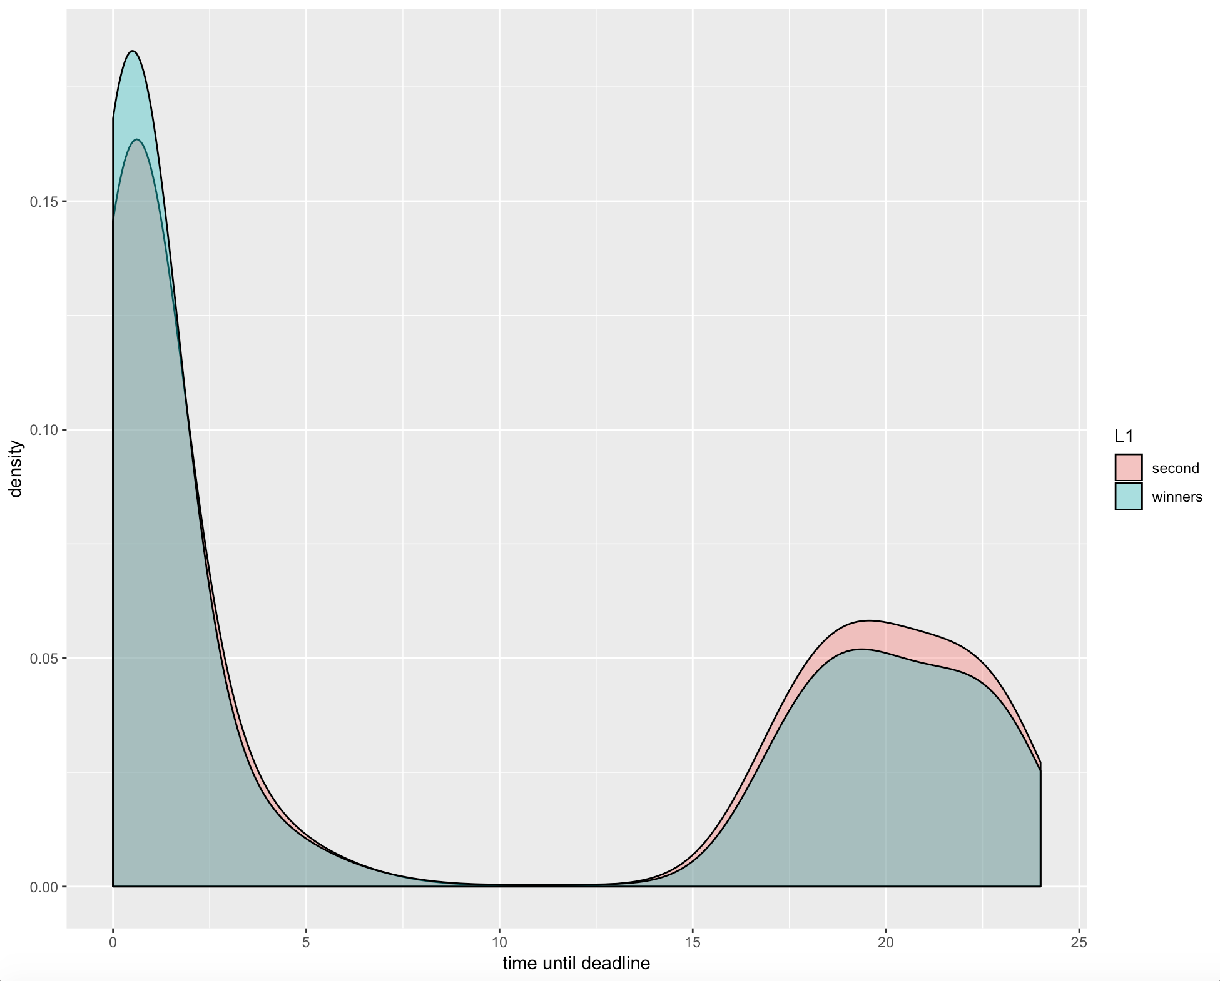

In order to provide supporting evidence for Claim 1 it is needed to estimate the following relationship:

where

and control for number of bidders .

Figure 2 shows the results of an OLS estimation of this LPM model. There is positive and significant relationship between given variables:

**Figure 2. LPM results**

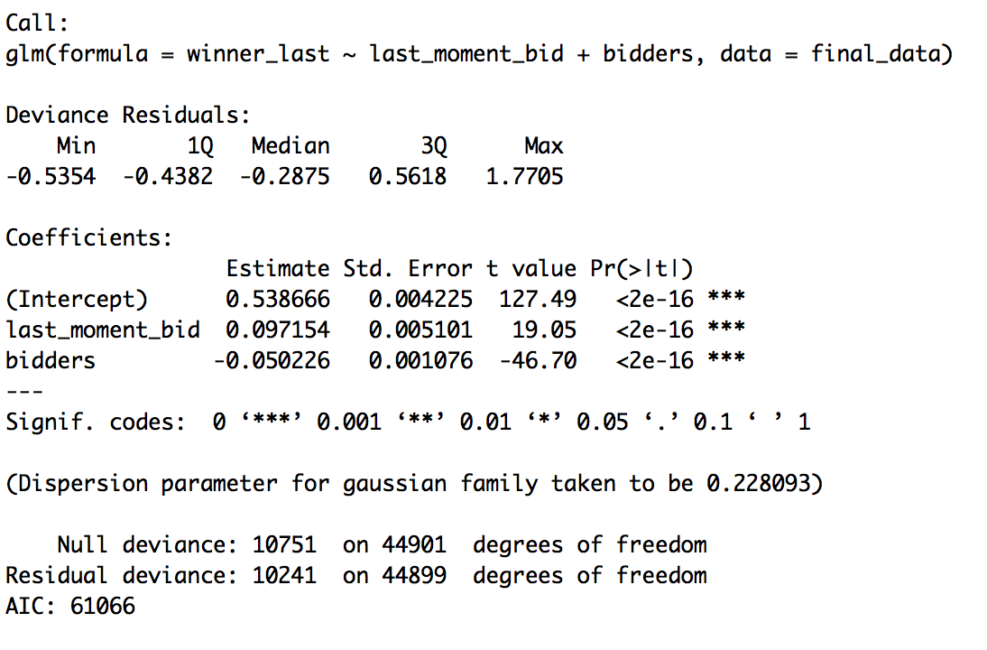

But since we have a binary dependent variable it is more appropriate to analyze this relationship using binary choice models. The results of Logit model are shown in Figure 3 and are significant as well. Thus it can be concluded that there is positive dependence between placing bid during last 15 minutes and winning an auction while being last bidder.

**Figure 3. Logit results**

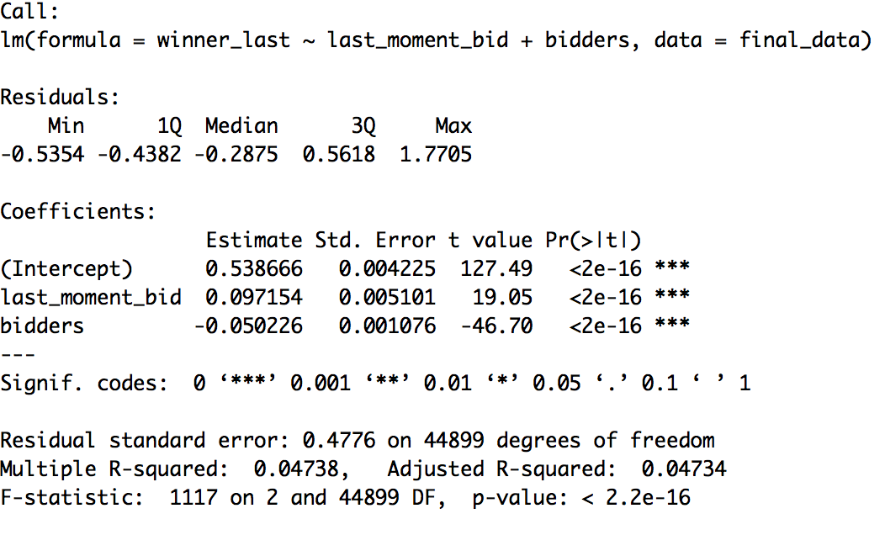

In addition, time differences in bids are expressed in Figure 4, which displays noticeable difference in cumulative density functions of timing decisions for a winner and a second-best bidder during last 36 hours until deadline. (Both CDF and PDF functions of all remaining bidders are roughly equal to second bidder’s function thus they are neglected during this analysis for simplification).

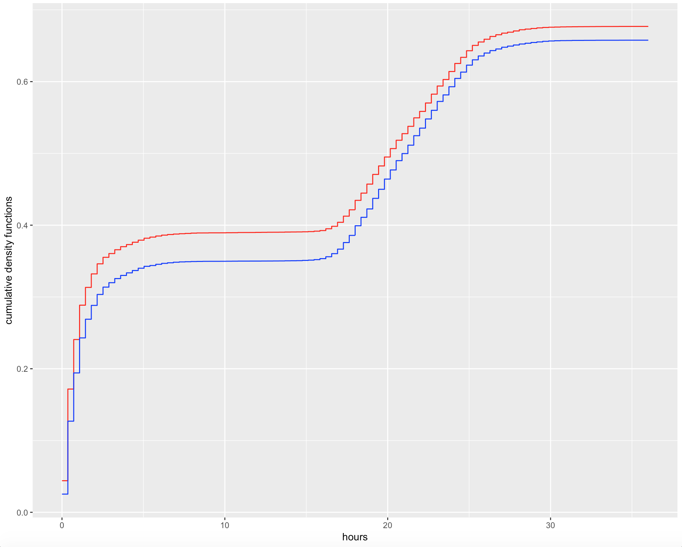

_winners

_ second

**Figure 4. Cumulative density of time**

Formally, the significance of difference in timing can be tested using two-sample Kolmogorov-Smirnov test:

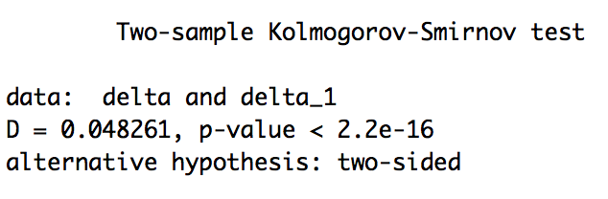It is evident that the time difference in bidding for winners (delta) and second-best bidders (delta_1) is significant.

Figure 5.

Moreover, it is reasonable to assume that if favored firm has information regarding all placed bids, it would try to lower its contract price as little as possible. Thus, the resulted price change between second best and winning bid should be low. Figure 5 shows the probability density of a relative percentage variation in price between two best bids. Clearly, more than 30% of resulted price changes are very insignificant (from 0 to 1%)

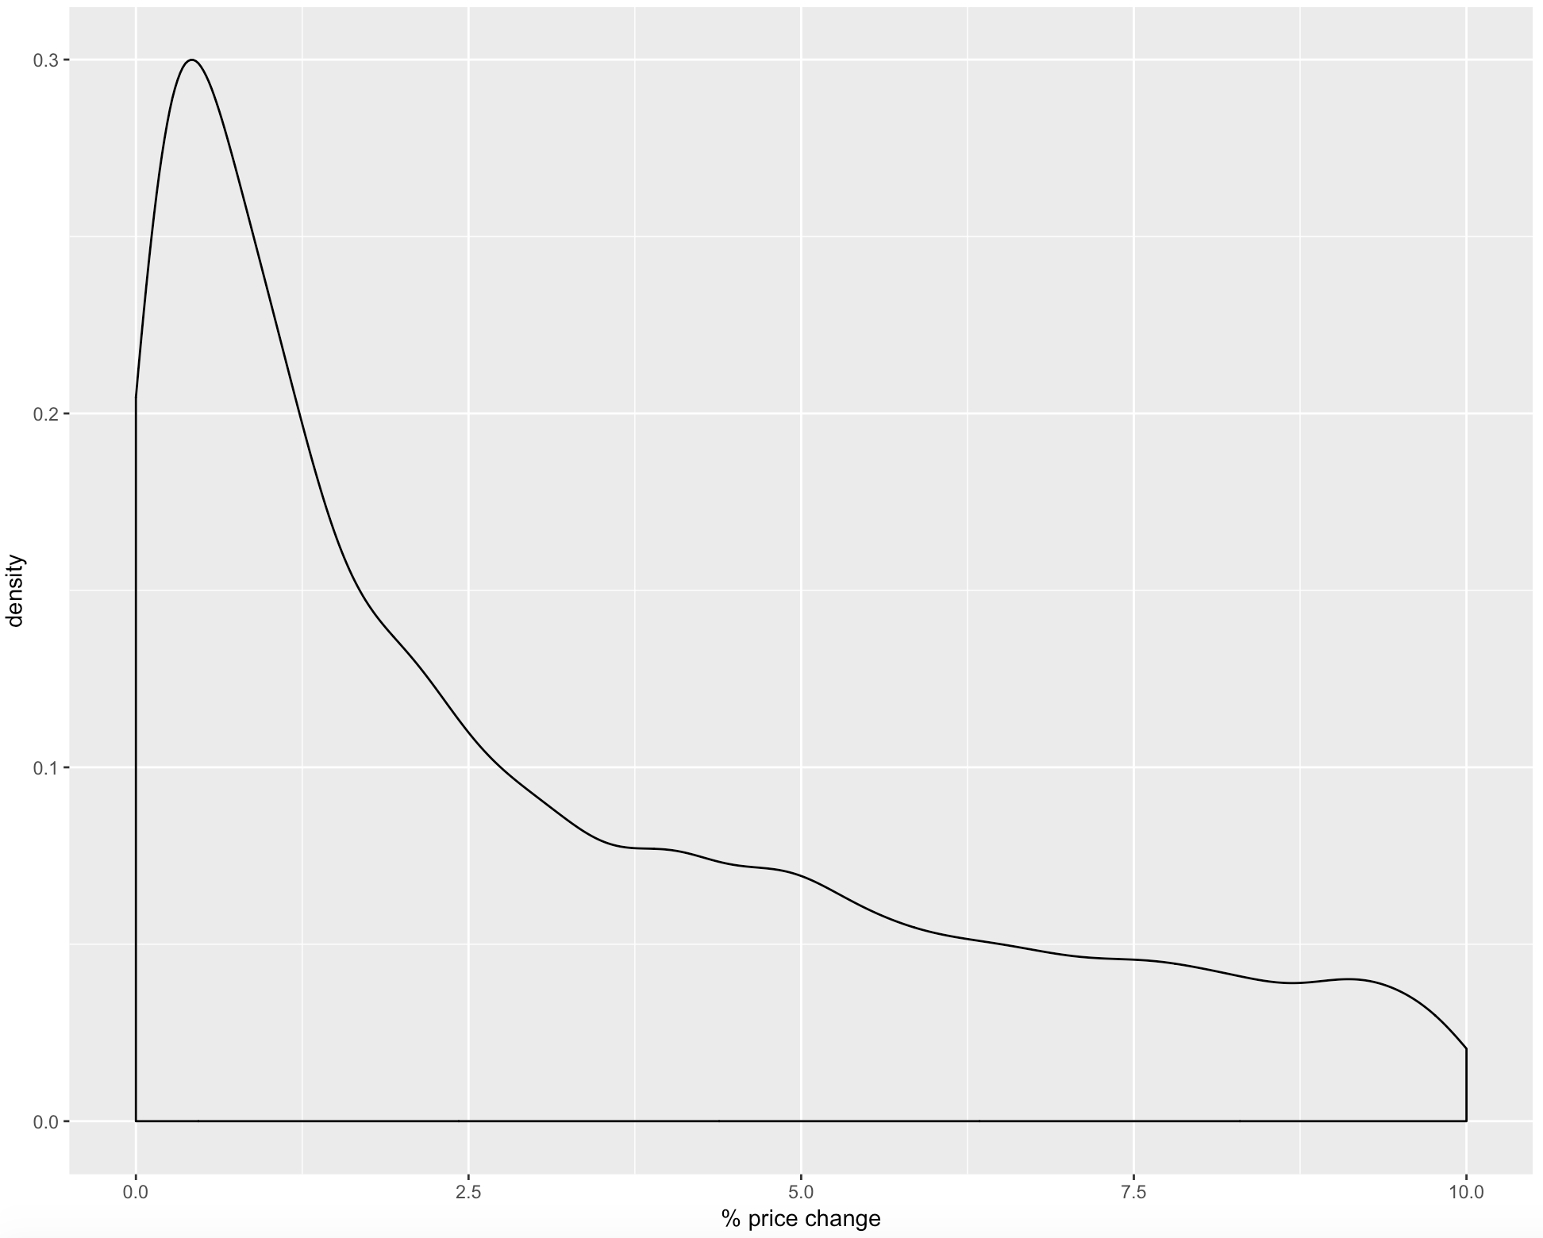

**Figure 6. PDF of relative price change**

**Claim 2: in presence of bid-rigging, relative price change between two best bids should be less than 1%**

# **4 The model**

As a result, the following analysis focuses on the following variables:

* Relative price change between two best bids (used as dependent variable corresponding to presence of corruption since price change <1% should indicate of a corruptive pattern)
* Number of bidders (should decline probability of corruption due to increased competition)
* Reserve price (more expensive auctions are more likely to be more corruptive due to bigger rent-seeking opportunities)
* Duration of an auction (corruption is more likely to be present in shorter auctions since if auctioneer and bidder collude prior to the start of auction, there is no incentive for auctioneer to extend the duration of tender)
* Timing of bids
* Position of winning bid in time

If corruption is present, there should be big share of auctions with small relative price change and winner placing bid last and late

The model estimates the following relationship:

where

Interactional dummy helps to accounts for two necessary for bid rigging conditions – bidding last and at the last moment.

Choosing 1% price change upper bound is associated with a big cluster in PDF from Figure 6.

In order for subsequent analysis to be possible, only those auctions where

* there are at least two bidders
* all submission times are different
* all submitted bids are different (reoccurring bids are simply removed from dataset)

are taken into account.

# **4.1 Testing the model**

Estimated coefficients are presented in Figure 7. It can be seen that all variables are significant and there exists positive dependence of suggested corruptive patterns on price change being less than 1% (). Moreover, reserve price also positively impacts dependent variable, whereas increase in number of bidders tends to negatively impact corruption pattern.

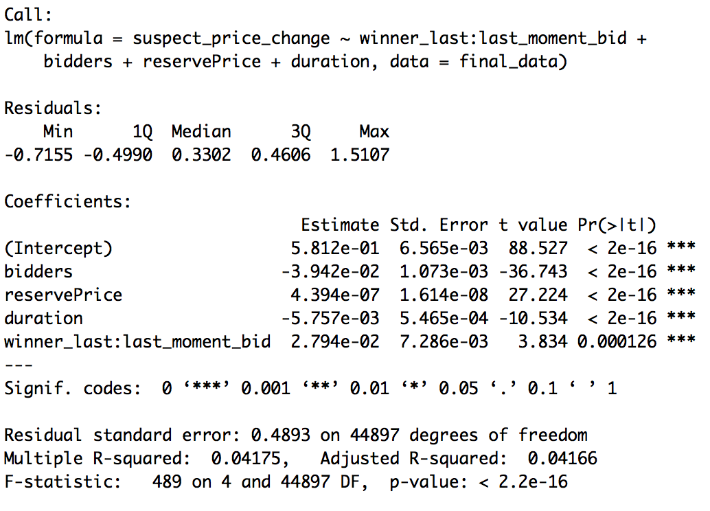**Figure 7. OLS results**

It can be concluded that obtained results are consistent with proposed corruption patterns.

# **5 Limitations**

Given research is faced with many limitations:

Firstly, the data is collected only on Moscow region thus there may be some regional differences of proportions of corruption in procurement. Thus, nothing can be concluded on a situation with corruption in sealed-bid procurements in Russia in general.

Secondly, there are other types of procurement auctions associated even with higher prices which were not analyzed in a given research and can also be corruptive/non-corruptive. Hence, nothing can be concluded on a corruption levels in Moscow in general.

Moreover, due to suspicious form of notifications and protocols of several auctions there is possibility that some of them may be conducted retroactively (auction was conducted before the information about its opening was placed in electronic system). It would be interesting to look at the dynamics of [http://zakupki.gov.ru](http://zakupki.gov.ru/) to examine corruptive patterns.

# **Conclusion**

Following research paper makes an attempt to analyze corruption patterns in sealed-bid public procurement auctions in Moscow. It proposes several corruptive patterns which may occur in this type of auctions: timing of bids and price variations across two best bidders are the variables of interest. Using publicly available data archive on 2014-2019 years and provides empirical estimates of this variables via OLS. Obtained results satisfy proposed hypotheses of presence of corruptive patterns in given data.

# **References**

1. Rose-Ackerman, S. (1999). «Corruption and government» // Cambridge University Press, Cam- bridge.
2. Shleifer A., Vishny R. Corruption // Quarterly Journal of Economics. 1993. Vol. 108, No. 3, pp. 599-617
3. [http://zakupki.gov.ru](http://zakupki.gov.ru/)
4. O. Compte, A. Lambert-Mogiliansky and T. Verdier “Corruption and Competition in Procurement Auctions» // The RAND Journal of Economics, Vol. 36, No. 1 (Spring, 2005), pp. 1-15

# А.А.Яковлев, О.А.Демидова, Е.А.Подколзина «Эмпирический анализ системы госзакупок в России», НИУ ВШЭ 2015

1. K.Kawai, J.Nakabayashi “Detecting Large-Scale Collusion in Procurement Auctions” 2014
2. Y. Lengwiler, E. Wolfstetter «Corruption in Procurement Auctions» // Chapter  in  SSRN Electronic Journal · January 2006

# J. J Laffont, J. Tirolle «Auction design and favoritism» // International Journal of Industrial Organization. Volume 9, Issue 1, March 1991, Pages 9-42

# F.Menezes, P.Monteiro «Corruption and Auctions» // Journal of Mathematical Economics 42(1):97-108 · February 2006

1. Olken, B «Monitoring corruption: evidence from a field experiment in Indonesia» // Journal of Political Economy, 115(2):200–249 (2007).
2. L. Arozamena, F.Weinschelbaum «The effect of corruption on bidding behaviour in first-price auctions» // European Economic Review 53 (6), 645-657 (2009)
3. B. A. Olken, R. Pande, «Corruption in Developing Countries »// MIT, Harvard University February 2012
4. D. Treisman «The Causes of Corruption» // A Cross-National Study Article  in  Journal of Public Economics · February 2000

1. OECD, Implementing the OECD Principles for Integrity in Public Procurement: Progress Since 2008 (2013)

   <https://www.oecd-ilibrary.org/governance/implementing-the-oecd-principles-for-integrity-in-public-procurement_9789264201385-en>
2. <https://www.interfax.ru/russia/646259>
3. [http://zakupki.gov.ru](http://zakupki.gov.ru/)